Assignment No 2

1. Write a shell script to display your permanent address.

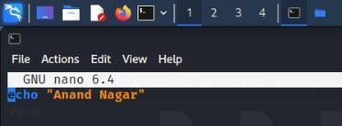

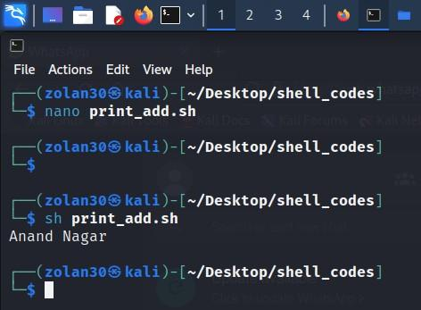

1. Write a shell script to take input from the user and display it.

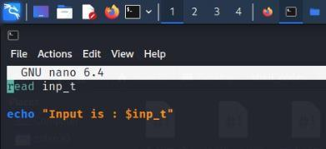

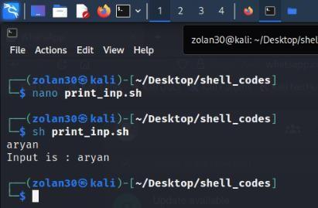

1. Write a shell script to demonstrate use of command line arguments.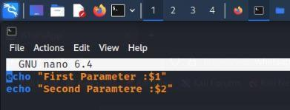
2. Write a shell scrpit to add two numbers where both the numbers are user inputs.
3. Write a shell script to check whether a number n is even or odd, where n is user input.
4. Write a shell script to input 10 numbers in array and find second largest number in it.
5. Write a shell script to check whether a number n is palindrome or not, where n is user input.
6. Write a shell script to check grade of a student as follows:
7. Total marks of the student=100

If student ‘s mark>= 90,grade is O .

If student ‘s mark>=80 and marks<90, grade is E.

If student ‘s mark>=70 and marks<80, grade is A.

If student ‘s mark>= 60 and marks<70, grade is B.

If student ‘s mark>= 50 and marks<60, grade is C.

If student ‘s mark < 50, grade is F.

1. Write a shell script to check if input character is vowel or not using case control statement.
2. Write a shell script to sort an array of n element using bubble sort, where n is user input.
3. Write a shell script to search an element from an array of n elements where n is user input
4. Write a shell script to check whether input string is palindrome or not.
5. Write a shell script to create a file and count number of lines, number of words and number of characters from the file.
6. Write a shell script to search a pattern from a file, where filename is user input.